ToBe Fit, The Juggling Nutrition Magician Show
Live + Virtual Is Coming!

Contact: Barbara Storper, MS, RD / Executive Director, Nutritionist / barbara@foodplay.com / 413-883-1057

Date of Live-Stream Performance: Time(s):
Place:
Sponsoring Organization:
Contact Person: Phone: Email:

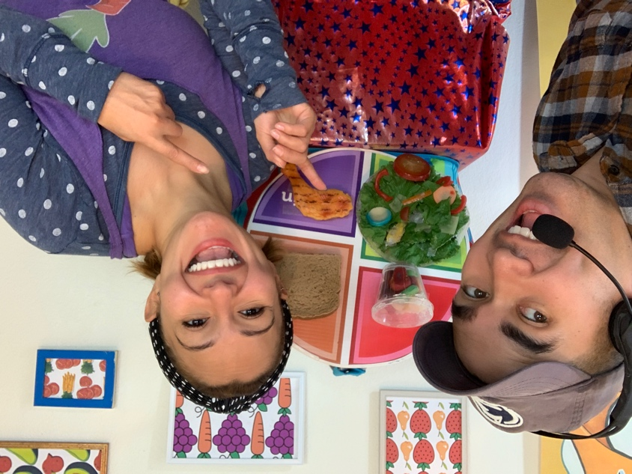

ToBe Fit - The Juggling Nutrition Magician Show is coming to town VIRTUALLY to help our kids take charge of growing up healthy, happy, and fit! This enchanting live-stream performance features amazing feats of juggling, music, magic, and audience participation to make good eating and active living – GREAT FUN!

Combating the national epidemic of poor eating habits and sedentary living, ToBe Fit and DJ Kale come to the rescue to help kids learn how to juggle the foods they eat to wind up with a balanced diet. Kids discover how to see through media messages and “Read It Before They Eat It!” so they’re not surprised by what’s inside. They’ll learn the difference between GO Foods and WHOA Foods, how to cut down on sugar and sweetened drinks, and be motivated to choose healthy fresh fruits and veggies instead of processed packaged junk food products. The show inspires children to have fun being active every day and make food choices that are good for their health and the health of the planet!

ToBe Fit, The Juggling Nutrition Magician Show features a 45 minute fun-filled, interactive performance, an exciting Question/Answer period where students get to ask ToBe Fit and nutritionist Barbara Storper, MS, RD, their burning questions about food, nutrition and play. And, schools receive a Follow-Up Resource Kit filled with printable activity sheets, lesson plans, and handouts to extend the nutrition learning throughout the year.
For more information, health tips, and to learn how to juggle: www.foodplay.com

ToBe Fit, The Juggling Nutrition Magician Show – LIVE + VIRTUAL is Coming!

More about FoodPlay Productions:
Launched this year as a reaction to CoVid , ToBe Fit, The Juggling Nutrition Magician Show – LIVE + VIRTUAL is touring schools, libraries, and communities to rave reviews to help turn the nation’s children on to healthy habits. Created by FoodPlay Productions, an Emmy Award-winning nutrition education theater company, the ToBe Fit Show is written and directed by Barbara Storper, MS, RD and performed by FoodPlay’s professional actors skilled in circus arts, theater, and education.

Founded in 1982 by Barbara Storper, MS, RD, a national leader in the field of children’s nutrition, FoodPlay Productions has reached over 5,000,000 school children across the country with their live theater shows, video kits, and resources. The organization has been honored with 10 national nutrition and media awards plus an EMMY Award for “Best Children and Youth TV Special”. Their programs are highly evaluated with evidence-based results showing dramatic improvements in children’s eating and physical activity habits…all delivered in a spirit of fun and celebration!

Note: High-resolution images and digital press releases are
available online at: Press Releases and Image Downloads

